The 3rd annual Dave Wolfe Memorial Ride will be held on Saturday, June 20th!

It is hard to believe another year has passed and finally warm biking weather is here again! Hopefully your schedule will allow for you, your family and friends to come out and ride with us on Saturday, June 20th, the day right before Father’s Day which is Sunday. I promise this date will not change! Hopefully we will have good weather again and we can all celebrate David's life on this day doing the thing that David loved so much, biking. As in the two previous years, we have reserved the Coffee Creek Pavilion and plans are once again to have a simple and low key event for those who knew and loved David. Everyone should plan to meet at the Pavilion parking lot at noon and then at approximately 12:15-12:30 PM we will head out for a scenic and enjoyable ride out to the Beverly Shores area and along Lake Michigan and return. It will be a 17.5 mile route and take about an hour and a half round-trip for most. There will once again be a mid-point stop for hydration and bananas at the Pavilion of Beverly Shores. The ride is planned as a relaxing, and enjoyable ride, not a race, and for the whole family of all ages.

Afterwards, there will be a picnic lunch with a BBQ cookout. Brats and Hot Dogs will be provided again at the picnic Pavilion at Coffee Creek. You should bring your own beverages and a side dish if desired as was done last year. The Pavilion shelter is supplied with a fireplace if it is cool. Group Shots for the past two years are below and you can see slide shows from 2007 and 2008 are at these two links.

On behalf of David’s family and myself, I hope to see you on Saturday, June 20th. Jeff Wolfe
(PS: I hope you can make it this year and if you let me know for sure, it will help me plan for having enough Brats and Wieners – Thanks!)

2007 Ride - Group at the half way point:

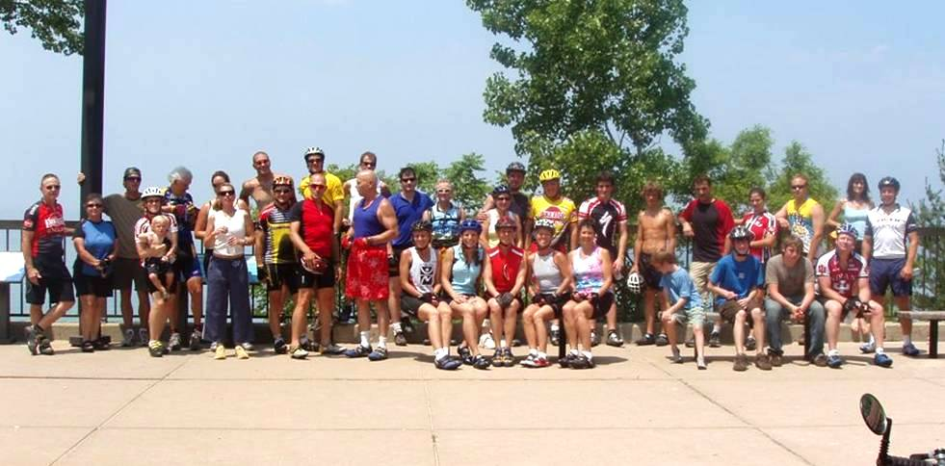

2008 Ride - Group at the half way point:

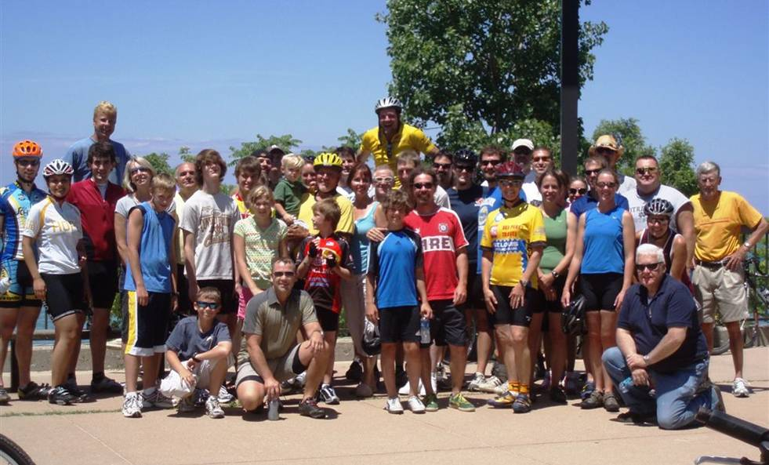

Note: If you send me your pictures after this year’s ride, I will include them on the album slide show for next year.

